




“Smart Payroll Insights: Transforming HR Data into Financial Intelligence”

Project Domain
[ Excel / Power BI]

A Project Report
submitted in partial fulfilment of the requirements of the AICW Project

by: Sneha Pahwa



Student Name
Sneha Pahwa

Student Email
Snehapahwa124@gmail.com
Guide
Umamaheswari

Institution:
[IBMR Business School]

Year - 2026
ACKNOWLEDGEMENT

We would like to take this opportunity to express our deep sense of gratitude to all individuals who helped us directly or indirectly during this project work.
Firstly, we would like to thank our supervisor Umamaheswari Mam, for being a great mentor and the best adviser we could have asked for. Their advice, encouragement, and constructive feedback served as a source of innovative ideas and inspiration, and were central to the successful completion of this project. The confidence shown in us was the biggest source of motivation throughout this journey.
We extend our sincere thanks to the Edunet Foundation, Microsoft, LinkedIn, and SAP for providing this fellowship opportunity, the learning resources, and the platform to develop and showcase our AI skills.
We are also grateful to our institution, IBMR Business School, for providing the necessary infrastructure and support throughout the project duration.
Finally, we thank our family and friends for their continuous encouragement and support.

ABSTRACT OF THE PROJECT

This project is part of the AICW (Artificial Intelligence in the Contemporary World) Fellowship Program, a collaborative initiative by Edunet Foundation in partnership with Microsoft, LinkedIn, and SAP. The fellowship is designed to equip students with practical, hands-on skills in Artificial Intelligence, Data Analytics, and Business Intelligence tools.
This project addresses the challenge of inefficient payroll data management and limited financial insights in organizations. Payroll datasets often contain inconsistencies such as missing values, duplicate records, and unstructured formats, which hinder accurate decision-making. The primary objective of this project is to clean, analyze, and transform raw payroll data into meaningful financial intelligence that supports HR and managerial decisions.
The methodology involves systematic data cleaning, including handling missing values, removing duplicates, and standardizing formats using Microsoft Excel. Advanced data analysis and visualization techniques are applied using Power BI to develop interactive dashboards. Additionally, AI-assisted tools such as Microsoft Copilot are utilized to enhance data processing efficiency and generate deeper insights.
Key outcomes of the project include the identification of salary distribution patterns, department-wise payroll expenses, employee cost trends, and anomalies in compensation. The dashboard enables stakeholders to monitor key payroll metrics, optimize workforce costs, and improve financial planning. Insights derived from the analysis help in enhancing transparency, ensuring compliance, and supporting strategic HR decisions.
In conclusion, the project successfully demonstrates how raw HR data can be transformed into actionable financial intelligence. By integrating data cleaning, visualization, and AI-driven analysis, the solution provides a scalable and efficient approach for payroll management, enabling organizations to make informed and data-driven decisions.

TABLE OF CONTENTS

Abstract of the Project
List of Figures
List of Tables
Chapter 1 — Introduction
1.1 Problem Statement
1.2 Motivation
1.3 Objectives
1.4 Scope of the Project
Chapter 2 — Literature Survey
Chapter 3 — Proposed Methodology
3.1 System Design
3.2 Modules / Components Used
3.3 Data Flow Diagram (DFD)
3.4 Advantages
3.5 Requirement Specification
Chapter 4 — Implementation and Results
4.1 Data Cleaning Results
4.2 Visualization / Output Results
4.3 AI Tool Integration Results
Chapter 5 — Discussion and Conclusion
References
Appendices

LIST OF FIGURES

Figure No. | Figure Title / Description | Page No.
Figure 1 | [Raw / uncleaned dataset screenshot] | 19
Figure 2 | [Cleaned dataset or validation summary screenshot] | 20
Figure 3 | [Main dashboard / report / output screenshot] | 22
Figure 4 | [Additional chart or visualization screenshot] | 22
Figure 5 | [AI tool (Copilot / Chatbot) in use screenshot] | 24
Figure 6 | [DFD Level 0 — Context Diagram] | 14
Figure 7 | [DFD Level 1 — Detailed Process Flow] | 15

LIST OF TABLES

Table No. | Table Title / Description | Page No.
Table 1 | [Raw dataset summary — field names, data types, row count] | 17
Table 2 | [Cleaned dataset summary — issues found and fixed] | 17-18
Table 3 | [Hardware Requirements] | 16
Table 4 | [Software Requirements] | 16
Table 5 | [Key findings / results summary] | 24

CHAPTER 1
Introduction
This chapter introduces the project undertaken as part of the AICW Fellowship Program. It outlines the background, the problem being addressed, the motivation behind this work, and the objectives and scope of the project. The fellowship projects span multiple domains including Data Analytics, Business Intelligence, Healthcare Analytics, Content Generation, and AI-assisted Reporting.
1.1 Problem Statement
Core Problem / Challenge
Organizations face significant challenges in managing payroll data due to its fragmented, inconsistent, and error-prone nature. Payroll information is often stored across multiple systems or maintained manually in spreadsheets, leading to issues such as duplicate records, missing values, incorrect calculations, and inconsistent formatting. These problems limit the ability to generate accurate financial insights from HR data.

Significance and Real-World Impact
The problem is highly critical as payroll directly affects employee compensation, organizational finances, and legal compliance. Inaccurate payroll processing can result in:
- Incorrect salary payments and deductions
- Violations of labour laws and tax regulations
- Financial losses and audit risks
- Reduced employee trust and satisfaction
Without proper data cleaning and analysis, organizations struggle to make informed decisions related to budgeting, workforce planning, and compensation strategies.

Target Users / Affected Stakeholders
The problem impacts multiple stakeholders:
- HR and Payroll Teams – face inefficiencies and high risk of manual errors
- Finance Departments – lack accurate data for financial planning and cost analysis
- Employees – experience lack of transparency in salary structure and deductions
- Management / Leadership – unable to derive actionable insights for strategic decisions

Limitations of Existing Approaches
Current payroll systems and practices have several limitations:
- Heavy reliance on manual or semi-automated processes
- Lack of data transparency for employees regarding salary breakdown
- Limited use of data analytics and visualization tools for insight generation
- Inadequate adoption of AI tools (e.g., Copilot) for automation and anomaly detection
- Difficulty in identifying patterns, trends, and discrepancies in payroll data

1.2 Motivation
Reason for Choosing the Project
This project is both professionally and academically meaningful as it focuses on the intersection of Human Resource management and data analytics. Payroll is a critical function in every organization, yet it is often overlooked from an analytical perspective. Working on this project provides practical exposure to handling real-world HR datasets and understanding financial implications through data.

Real-World Applications
- Enables organizations to analyze payroll expenses and optimize costs
- Helps in detecting salary anomalies and discrepancies
- Improves transparency in employee compensation structures
- Supports compliance with tax laws and labour regulations
- Assists HR teams in strategic workforce planning and budgeting

Impact on Organization / Domain
- Enhances accuracy and efficiency in payroll processing
- Reduces manual errors and operational risks
- Builds data-driven decision-making capabilities in HR and finance
- Improves employee trust and satisfaction through transparent insights
- Strengthens organizational compliance and financial control

Alignment with Industry Trends
- Increasing use of AI tools (e.g., Copilot, Chatbots) for data analysis
- Growing importance of Business Intelligence and Data Visualization
- Shift towards data-driven HR (HR Analytics / People Analytics)
- Demand for automation in financial and operational processes
- Integration of analytics into traditional business functions like payroll

1.3 Objectives
- To collect and understand the structure of the payroll dataset, including employee and salary-related attributes.
- To clean and preprocess raw payroll data by removing duplicates, handling missing values, and standardizing formats.
- To perform payroll and financial analysis using Excel tools such as formulas.
- To build interactive dashboards and visual reports using Power BI to effectively communicate payroll insights.
- To identify patterns such as department-wise salary distribution, payroll expenses, and deduction trends for better decision-making.
1.4 Scope of the Project
- This project covers data from an employee payroll dataset, including fields such as Employee ID, Department, Salary, Allowances, Deductions, Gross Salary, and Net Salary.
- The tools used are limited to Microsoft Excel, Power BI as part of the project requirements.
- The analysis focuses on data cleaning, payroll analysis, and visualization of financial insights.
- The project does not include real-time data integration, advanced predictive modeling, or machine learning algorithms.
- The dataset used is synthetically generated and may not fully represent real-world complexities.
- The project is intended as a fellowship-level academic project and not a fully deployed enterprise solution.

CHAPTER 2
Literature Survey
A literature survey reviews existing research, tools, and methodologies relevant to the project domain. It helps identify gaps that the current project aims to address.
2.1 Existing Work and Research
Overview of Existing Work
In the domain of Human Resource Analytics and Payroll Management, various tools and research studies highlight the importance of structured data handling and analytical decision-making. Traditional payroll systems rely heavily on Microsoft Excel, ERP systems, and database tools for managing employee compensation data. Additionally, Business Intelligence (BI) tools such as Power BI are widely used to create dashboards and visualize payroll insights.
Recent research emphasizes the growing role of Artificial Intelligence (AI) in automating data cleaning, improving accuracy, and generating insights. AI-powered tools such as Microsoft Copilot and AI chatbots are increasingly being adopted to assist in data analysis, report generation, and decision-making processes.

Existing Techniques and Tools

Excel-based Data Cleaning Techniques
- Use of formulas, sorting, filtering, and Pivot Tables for data preprocessing
- Manual handling of missing values, duplicates, and inconsistencies

Power BI Dashboards
- Visualization of key metrics such as payroll cost, salary distribution, and department-wise expenses
- Interactive dashboards for business decision-making

ERP and Payroll Systems
- Automation of salary processing, tax calculations, and compliance tracking
- Limited flexibility for advanced analytics and customization

AI and Prompt Engineering Tools
- Microsoft Copilot for automated insights and data summarization
- AI chatbots for generating reports and improving productivity

Limitations of Existing Solutions
- Despite advancements, existing systems face several challenges:
- Data Fragmentation: Payroll data is often scattered across multiple systems
- Manual Dependency: High reliance on manual data cleaning increases error risk
- Limited Insight Generation: Focus remains on processing rather than analytics
- Lack of Transparency: Employees have limited visibility into salary structures
- Underutilization of AI: AI tools are not fully leveraged for payroll intelligence

Research Gap and Project Contribution
This project addresses these limitations by integrating data cleaning, analysis, visualization, and AI-assisted techniques into a unified workflow. It transforms raw payroll data into actionable financial insights.
Key contributions include:
- Structured and cleaned payroll dataset for accurate analysis
- Use of Excel and BI techniques for financial insight generation
- Integration of AI tools (Copilot and Chatbots) to enhance efficiency
- Improved transparency and data-driven decision-making in HR

References
- Microsoft Corporation. Microsoft Excel Documentation. Available at: https://support.microsoft.com/excel
- Microsoft Corporation. Power BI Documentation. Available at: https://learn.microsoft.com/power-bi
- Microsoft Corporation. Microsoft Copilot Overview. Available at: https://copilot.microsoft.com
- Edunet Foundation. AICTE–Edunet Foundation AI & Data Analytics Program Guidelines, 2026
- LinkedIn Learning. AI and Data Analytics Courses, 2026
- International Business Machines Corporation. The Role of AI in Data Analytics and Automation, IBM Research Insights
- Institute of Electrical and Electronics Engineers. Research Papers on Business Intelligence and Data Visualization

2.2 Tools and Technologies Review
This project utilizes a combination of data analysis, visualization, and AI-assisted tools to transform payroll data into actionable insights:
- Microsoft Excel
Widely used for data cleaning, preprocessing, and initial analysis. Techniques such as filtering, sorting, formulas, and data validation are applied to handle missing values, remove duplicates, and structure payroll datasets effectively.
- Microsoft Power BI
A powerful Business Intelligence tool used to create interactive dashboards and visual reports. It enables visualization of key payroll metrics such as salary distribution, department-wise expenses, and overall payroll cost, supporting better decision-making.

- AIChatbots(e.g.chatgpt)
Used for generating reports, summarizing insights, assisting in documentation, and supporting prompt-based analysis. These tools improve efficiency and help in interpreting complex payroll data.
- ExcelAdvance(AdditionalTool/Technique)
Advanced Excel capabilities such as logical functions.

2.3 Gaps Identified

- Most existing research emphasizes complex machine learning models, while practical, tool-based solutions (Excel, BI tools) for non-technical users are less explored.
- There is limited structured implementation of AI tools like Copilot integrated with Excel for payroll-specific analysis, especially in academic or student-level projects.
Existing payroll systems focus more on transaction processing rather than insight generation and financial intelligence.
- Data transparency issues persist, where employees do not have clear visibility into salary components, deductions, and net pay calculations.
- There is a lack of focus on end-to-end workflow integration (data cleaning → analysis → visualization → AI insights) within a single project framework.
- Prompt engineering practices for HR and payroll analytics are still evolving and lack standardized guidelines.
- Most tools do not effectively address data quality issues (duplicates, missing values, inconsistencies) before analysis, leading to inaccurate insights.
- Limited emphasis on using analytics for strategic HR decision-making, such as cost optimization and workforce planning.

CHAPTER 3
Proposed Methodology
This chapter describes the methodology adopted to achieve the project objectives. It covers the system design, modules used, data flow, advantages, and requirement specifications.
3.1 System Design
The system is designed to analyse employee payroll data and convert it into meaningful insights using data processing and visualization techniques. The workflow begins with raw payroll data and ends with an interactive dashboard for decision-making.

Data Source / Input
The data used in this project is an Excel-based payroll dataset containing approximately 1000 employee records.
The dataset includes:
- Employee ID
- Employee Name
- Department
- Designation
- Basic Salary
- Allowances
- Deductions
- Net Salary
This dataset serves as the primary input for analysis
Data Cleaning
To ensure data quality and accuracy, the following preprocessing steps were performed:
- Removed duplicate employee records
- Handled missing/null values appropriately
- Standardized department and job role names for consistency
- Corrected data types (e.g., salary as numeric, names as text)
- Cleaned inconsistent or incorrect entries

Analysis / Processing
Data analysis was performed using Excel and Power BI:
- Calculated key KPIs such as:
  - Average Salary
  - Total Payroll Cost
  - Employee Count
- Used Power BI DAX measures for advanced calculations
- Analyzed salary distribution across departments and roles

Visualization / Output
The final output of the system is an interactive Payroll Dashboard created in Power BI:
- KPI cards showing key metrics (Average Salary, Total Employees, Payroll Cost)
- Department-wise salary comparison charts
- Filters (slicers) for dynamic analysis
- Visuals such as bar charts, pie charts, and summary tables
The dashboard enables easy interpretation of payroll data and supports data-driven decision-making.

3.2 Modules / Components Used
Module 1 — Data Ingestion
- The raw payroll dataset is loaded into Microsoft Excel and Power BI.
- The dataset contains employee-related information such as Employee ID, Department, Salary, Job Role, Experience, and Attendance.
- Data is imported into Power BI using Excel as the primary data source.

Module 2 — Data Cleaning
- Removed duplicate records to maintain data integrity.
- Handled missing/null values using appropriate techniques.
- Standardized inconsistent entries (e.g., department names, job roles).
- Ensured correct data types (numeric for salary, text for names, etc.).

Module 3 — Data Analysis
- Performed analysis using: DAX measures in Power BI
- Calculated key performance indicators (KPIs):
  - Average Salary
  - Total Payroll Cost
  - Employee Count
- Conducted department-wise and role-wise salary analysis
Module 4 — Visualization / Report Generation
- Developed an interactive dashboard using Power BI
- Created:
  - KPI Cards
  - Bar Charts (department-wise salary)
  - Pie Charts (employee distribution)
- Used filters/slicers for dynamic data exploration
- Generated a visual report for better understanding of payroll insights

Module 5 — AI Integration
- Utilized AI tools (such as ChatGPT) for:
  - Generating insights from data
  - Assisting in report writing and content generation
  - Enhancing interpretation of dashboard results

Module 6 — Dashboard Interaction (Project-Specific)
- Enabled user interaction through slicers and filters
- Allows users to view data based on:
  - Department
  - Job Role
- Provides dynamic and real-time insights for decision-making

3.3 Data Flow Diagram (DFD).
A Data Flow Diagram (DFD) is a graphical representation of how data flows through the system. It illustrates the movement of data from input to processing and finally to output, showing how the system transforms raw data into meaningful insights.

DFD Level 0 — Context Diagram
The Level 0 DFD represents the entire system as a single process. It shows the input and output without detailing internal processes.
Description:
- Input: Raw Payroll Data (Excel dataset containing employee details such as salary, department, job role, etc.)
- Process: Payroll Analytics System
- Output: Cleaned Data, Interactive Dashboard, and Analytical Reports

Flow Representation:
Raw Payroll Data → [Payroll Analytics System] → Dashboard / Reports / Insights

DFD Level 1 — Detailed Process Flow
The Level 1 DFD breaks the main system into multiple sub-processes to show detailed data flow.
Sub-process 1: Data Loading and Validation
- Loads payroll data from Excel into the system (Power BI)
- Validates data structure and checks for missing or incorrect entries
Sub-process 2: Data Cleaning and Transformation
- Removes duplicate records
- Handles null/missing values
- Standardizes formats (department names, job roles)
- Converts data into proper formats for analysis
Sub-process 3: Analysis and AI Processing
- Performs calculations using DAX measures
- Generates KPIs such as:
  - Average Salary
  - Total Payroll Cost
  - Employee Count
- Uses AI tools (if applicable) for insights and summaries
Sub-process 4: Visualization and Report Generation
- Creates interactive dashboards using Power BI
- Generates charts, graphs, and KPI cards
- Produces final reports for decision-making.
Raw Data → Data Loading → Data Cleaning → Data Analysis → Visualization → Dashboard Output

3.4 Advantages
List the key advantages of your proposed approach:
- Automates repetitive data cleaning tasks, reducing manual effort and improving efficiency in handling payroll data.
- Provides clear and interactive visual insights through dashboards, making it easy for non-technical users (e.g., HR managers) to understand salary trends and patterns.
- Leverages AI tools (ChatGPT) to assist in analysis, report generation, and insight extraction, thereby reducing human error and saving time.
- Scalable in nature, allowing the same approach to be applied to larger datasets or extended to other domains like sales, finance, or HR analytics.
- Cost-effective solution, as it uses widely available tools like Microsoft Excel and Power BI, which are part of the Microsoft ecosystem.
- Improves decision-making, by providing real-time insights into payroll distribution, employee count, and departmental performance.
- Enhances data accuracy and consistency through proper data cleaning and validation techniques.
- User-friendly interface, with interactive filters and slicers that allow users to explore data dynamically without technical expertise.

3.5 Requirement Specification
Hardware Requirements
Component | Specification
Processor | Intel Core i3 or higher (i5/i7 recommended)
RAM | Minimum 4 GB (8 GB recommended)
Storage | Minimum 50 GB free disk space
Display | 1366 x 768 resolution or higher
Internet | Required for Copilot / Chatbot access
Software Requirements
Software | Details
Operating System | Windows 10 / 11 or macOS
Microsoft Excel | Microsoft 365 (Excel with Copilot) / Excel 2019+
Power BI Desktop | Latest version (free download from Microsoft)
Microsoft Copilot | Integrated via Microsoft 365 subscription
AI Chatbot | ChatGPT / Google Gemini / Microsoft Copilot (web)
Web Browser | Google Chrome / Microsoft Edge (latest version)

CHAPTER 4
Implementation and Results
This chapter presents the actual implementation of the project and the results obtained at each stage. Screenshots of dashboards, cleaned datasets, or generated content should be inserted where indicated.
4.1 Data Cleaning Results

Dataset Source
The dataset used in this project is a manually created Excel dataset, designed specifically for payroll analysis. It contains structured employee information such as Employee ID, Department, Job Role, and Salary. The dataset was created to simulate real-world payroll scenarios for analytical and visualization purposes.

Original Dataset Size
- 1000 rows (employee records)
- 7 columns including:
  - Employee ID
  - Employee Name
  - Department
  - Designation
  - Basic Salary
  - Allowances
  - Deductions
  - Net salary

Issues Found
During initial inspection of the dataset, the following issues were identified:
- Minor inconsistencies in text fields (department and job role naming)
- Possible duplicate entries
- Missing/null values in some records
- Incorrect data types (e.g., salary or experience not properly formatted as numeric)

Cleaning Steps Applied
The following steps were performed using Excel and Power BI:
- Removed duplicate records using Excel tools
- Checked and handled missing/null values appropriately
- Standardized department and job role names for consistency
- Converted data types:
  - Salary → Numeric format (for calculations and KPIs)
  - Employee ID → Text/Numeric (as required)
  - Department & Job Role → Text format
- Verified dataset for errors and inconsistencies
- Imported the cleaned dataset into Power BI for further analysis

Cleaned Dataset Size
- Final dataset contains 1000 rows and 7 columns
- Data quality significantly improved with consistent formatting and correct data types

Figure 1: Raw dataset

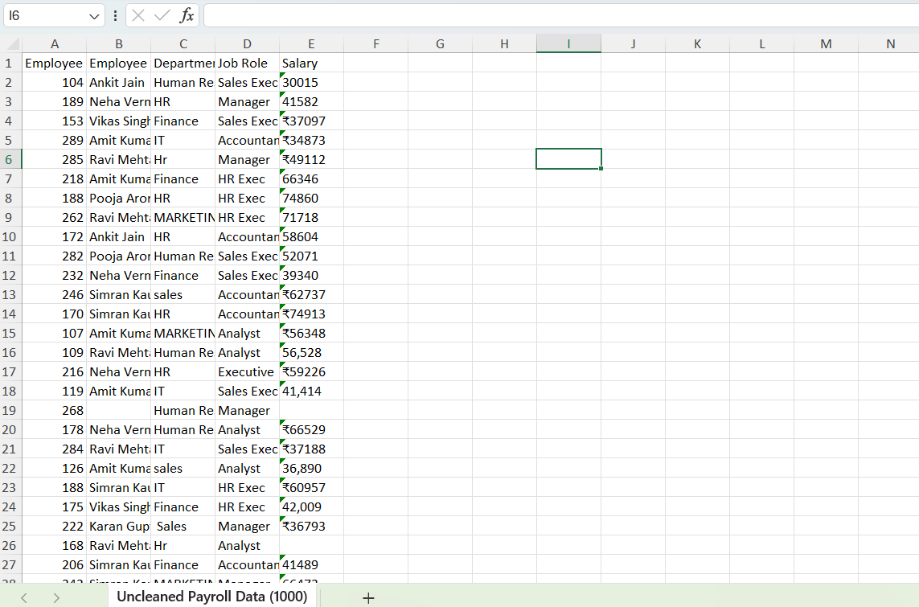

Figure 2: cleaned dataset

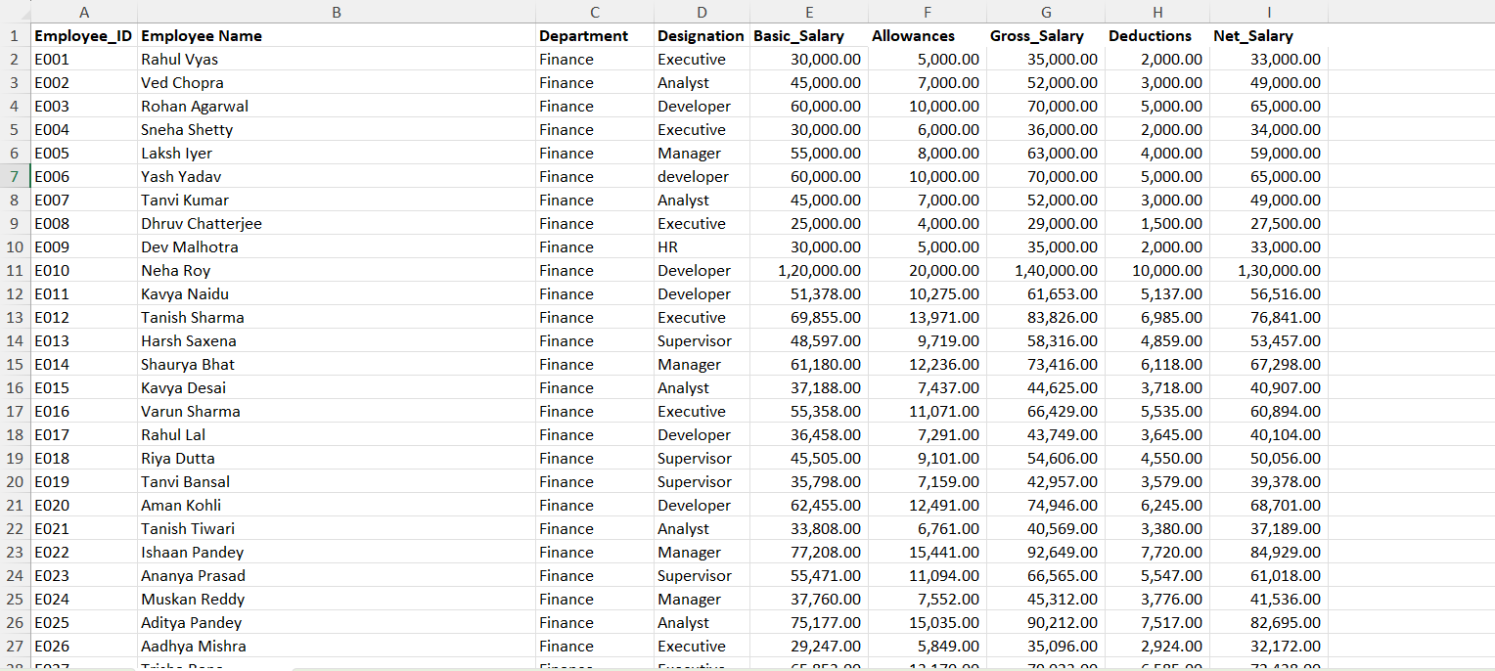

4.2 Visualization / Output Results
This section presents the key visualizations and dashboard outputs generated using Power BI for payroll analysis.

Dashboard / Chart 1: KPI Summary Cards
- This section displays key performance indicators (KPIs) including:
  - Total Deductions (5M)
  - Total Payroll Cost (56M)
  - Total Employees (1000)
  - Average Salary (55.55K)
- These KPIs provide a quick overview of the organization’s payroll structure and financial distribution.

Dashboard / Chart 2: Top 5 Departments – Net Salary Distribution (Bar Chart)
- This chart shows the net salary distribution across the top 5 departments:
  - Finance
  - IT
  - Operations
  - HR
  - Sales
- It helps identify which departments contribute most to overall salary expenditure.

Dashboard / Chart 3: Employee Net Salary Details (Table)
- Displays individual employee salary details including:
  - Employee Name
  - Net Salary
- Helps in detailed analysis and comparison of employee earnings.

Dashboard / Chart 4: Salary Structure Breakdown by Department (Stacked Bar Chart)
- Shows salary components across departments:
  - Basic Salary
  - Allowances
  - Deductions
- Helps in understanding how total salary is structured within each department.

Dashboard / Chart 5: Total Employees by Designation (Pie Chart)
- Represents distribution of employees based on designation:
  - Developer
  - Executive
  - Analyst
  - Manager
- Helps analyse workforce composition within the organization.

Dashboard / Chart 6: Average Net Salary by Department (Donut Chart)
- Displays the average net salary across departments:
  - Marketing
  - HR
  - Sales
  - Finance
- Helps compare salary trends between departments.

Dashboard / Chart 7: Filter by Designation (Slicer)
- Provides an interactive filter to view data based on designation:
  - Analyst, Assistant, Developer, Executive, HR, etc.
- Enables dynamic and customized analysis of payroll data.

Figure 3: Dashboard

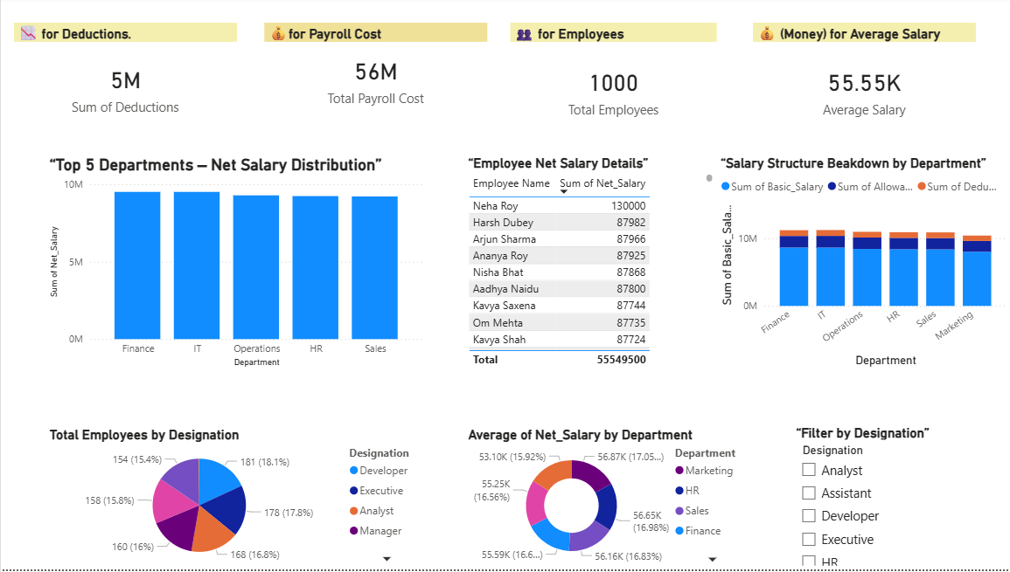

Figure 4: visualization

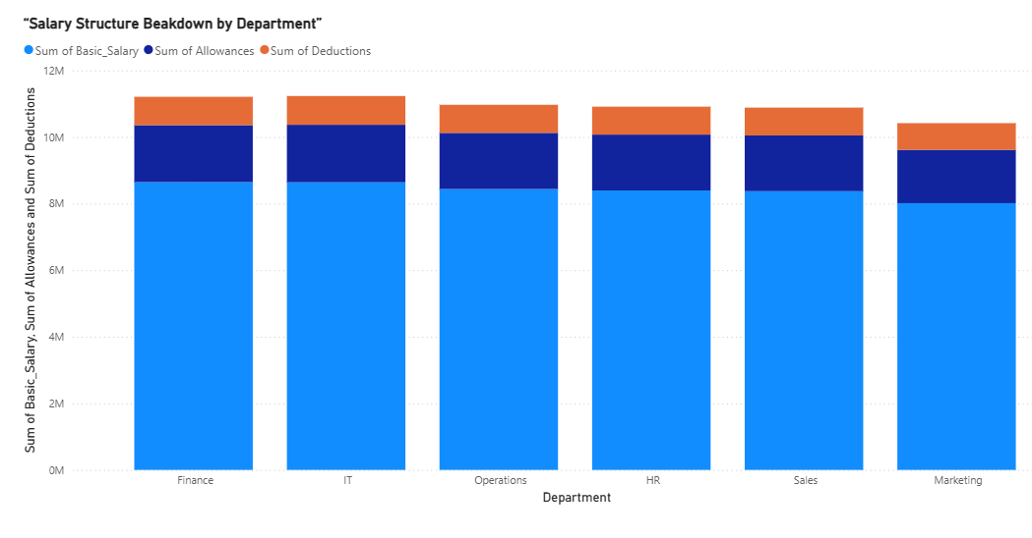

4.3 AI Tool Integration Results
Tool Used
- ChatGPT (AI Chatbot) was used to assist in data analysis, content generation, and project documentation.

Prompts Used
Some of the key prompts used during the project include:
- “Generate insights from a payroll dataset including salary distribution and department-wise analysis.”
- “Explain data cleaning steps for payroll data in Excel and Power BI.”
- “Create content for dashboard explanation and project documentation.”

Output Quality
- The AI-generated outputs were:
  - Accurate and relevant to the project requirements
  - Well-structured and easy to understand
  - Helpful in generating clear explanations and insights
- Minor modifications were made to align the content with the actual dataset and dashboard.

How It Enhanced the Project
- Improved efficiency by reducing time required for writing documentation
- Assisted in generating meaningful insights from the dataset
- Helped in structuring the report in a professional format
- Reduced manual effort in explaining technical concepts
- Supported better understanding of data analysis and visualization

Figure 5: Use of ChatGPT for generating payroll insights and supporting project documentation.

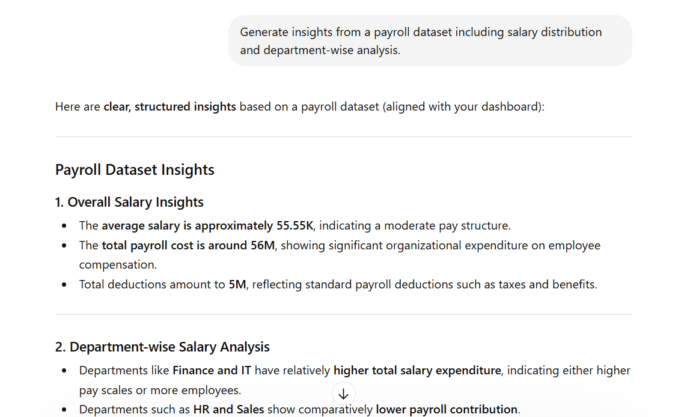

CHAPTER 5
Discussion and Conclusion
5.1 Key Findings
The following key findings were derived from the payroll analytics project:

- Key Finding 1: After data cleaning, inconsistencies such as duplicate records, missing values, and formatting errors were resolved, which significantly improved the accuracy and reliability of the dashboard insights.

- Key Finding 2: The analysis revealed that the average salary is approximately 55.55K, indicating a consistent and balanced pay structure across the organization.

- Key Finding 3: The total payroll cost is around 56M, highlighting the overall financial commitment of the organization towards employee compensation.

- Key Finding 4: Department-wise analysis showed that Finance and IT departments contribute the highest to payroll expenses, while HR and Sales have comparatively lower contributions.

- Key Finding 5: The salary structure analysis indicated that basic salary forms the major portion, followed by allowances, with deductions being the smallest component.

- Key Finding 6: Employee distribution across designations such as Developers, Executives, Analysts, and Managers is relatively balanced, supporting efficient organizational functioning.

- Key Finding 7: The use of AI tools (ChatGPT) significantly reduced the time required for documentation and insight generation, making the project more efficient and structured.

5.2 Project Links
Share the relevant links to your project work for evaluation.
- snehapahwa124-jpg/sneha-pahwa-AICW-Project: AICW project PPT on Payroll Analytics Dashboard using Power BI and Excel, focusing on salary insights, KPIs, and data-driven decision-making.
- Video Recording of Project Demonstration: [Paste your YouTube / Google Drive / OneDrive video link here]

5.3 Limitations
The following limitations were identified in the current project:

- Limitation 1: The project is based on a manually created dataset, which may not fully represent real-world complexities and variations in payroll data.

- Limitation 2: The dataset size is limited (1000 records), so insights may not scale accurately for large enterprise-level datasets.

- Limitation 3: The dashboard does not support real-time data updates, as it relies on static Excel data.

- Limitation 4: AI tool usage (ChatGPT) was limited to content generation and basic insights, and not fully integrated into automated data processing.

- Limitation 5: Some advanced analytics features such as predictive analysis or forecasting were not implemented.

5.4 Future Work
The following enhancements can be made to improve and extend the project:

- Integrate real-time data pipelines using Power BI Service or API connections for live data updates
- Apply machine learning models such as salary prediction, trend analysis, and anomaly detection
- Develop a web-based or mobile interface using Power Apps for easier access by non-technical users
- Expand the dataset to include more realistic and diverse HR data (e.g., performance, bonuses, employee turnover)
- Enhance dashboard by adding:
  - Advanced filters
  - Drill-down analysis
  - Predictive visuals
- Improve AI integration by creating a standardized prompt system for automated insights and reporting

5.5 Conclusion
This project successfully demonstrated the use of Microsoft Excel and Power BI to analyze and visualize payroll data effectively. The main objective was to transform raw payroll data into meaningful insights through data cleaning, analysis, and interactive dashboard creation.
The project achieved all its objectives, including:
- Cleaning and preparing the dataset
- Performing salary and department-wise analysis
- Developing an interactive dashboard with key performance indicators
The results showed that the payroll system is well-structured, with balanced salary distribution across departments and roles. The dashboard provides clear and actionable insights that can support decision-making in HR and finance departments.
Additionally, the use of AI tools like ChatGPT helped in generating insights and documentation efficiently, improving overall productivity.
Overall, this project enhanced practical knowledge in data analytics, Power BI visualization, and AI-assisted reporting, making it valuable for real-world business applications.

REFERENCES

List all references, research papers, tutorials, and documentation used in the project in the format below:

[1] Microsoft Corporation. Microsoft Excel Documentation. Available at: https://support.microsoft.com/en-us/excel
[2] Microsoft Corporation. Power BI Documentation. Available at: https://learn.microsoft.com/en-us/power-bi/
[3] Microsoft Corporation. Microsoft Copilot — AI-Powered Productivity. Available at: https://copilot.microsoft.com
[4] Edunet Foundation. AICW Fellowship Program Guidelines. 2026.
[5] OpenAI. ChatGPT — AI Conversational Model Documentation. Available at: https://openai.com/chatgpt

APPENDICES

Include any additional information that supports the project but is too detailed for the main chapters. This may include:

Appendix A — Sample Dataset

A sample of the raw payroll dataset used in the project is shown below:
Employee ID | Employee Name | Department | Job Role | Salary
101 | Rahul Sharma | HR | Manager | 50000
102 | Priya Singh | Hr | Executive | ₹45000
103 | Amit Kumar | Sales | Sales Exec | 40,000
104 | Neha Verma | Marketing | Analyst
105 | Ravi Mehta | sales | Sales Exec | 38000
101 | Rahul Sharma | HR | Manager | 50000
106 |  | Finance | Accountant | 42000
07 | Karan Gupta | Human Resource | HR Exec | 39000
108 | Simran Kaur | Marketing | Analyst | 41000
109 | Ankit Jain | Sales | Manager | ₹55000

(This sample represents the uncleaned dataset before preprocessing.)

Appendix B — Key Excel Formulas / DAX Measures Used

Excel Formulas
- =COUNTIF(A:A,A2) — Used to identify duplicate Employee IDs
- =TRIM(A2) — Used to remove extra spaces in text fields
- =IF(ISBLANK(A2),"Missing",A2) — Used to handle missing values
- =VALUE(A2) — Used to convert salary from text to numeric format

Power BI DAX Measures
- TotalPayrollCost
Total Payroll = SUM(Payroll[Salary])
- AverageSalary
Average Salary = AVERAGE (Payroll [Salary])
- TotalEmployees
Total Employees = COUNT(Payroll[Employee ID])
- TotalDeductions(ifcalculated)
Total Deductions = SUM(Payroll[Deductions])

Appendix C — AI Prompts Used

The following prompts were used with ChatGPT during the project:
- Prompt
“Generate insights from a payroll dataset including salary distribution and department-wise analysis.”
- Prompt
“Explain data cleaning steps for payroll data in Excel and Power BI.”
- Prompt
“Create structured content for a payroll dashboard project report.”
